Synrc Contacts

Synrc Contacts Application for Vista is about organizing, import/export, syncing your Address Books with Google Contacts, Microsoft Outlook, NOKIA Phones, Windows Contacts local folder, LDAP Directory, Yahoo! Contacts and Windows Live Contacts.

[Download Synrc Contacts](http://sync.codeplex.com/Release/ProjectReleases.aspx?ReleaseId=25299) BETA

Features:

1. Puritan and Minimalistic interface
2. Symmetric synchronization (no master and slave)
3. Original [Sync Replication Protocol](http://synrc.com/syncm/ReplicationProtocol.txt)
4. No data loss, duplicating or inconsistance
5. Designed for Multicore CPUs
6. Open architecture
7. No passwords stored
8. Instant full cross-field search
9. Supports Windows Sync Center

Your contacts from around mobile phones, mail programs, social services are managed without warry of any data loss, contacts duplicating or data inconsistance.

Actually one button functionality is not true. You can see all adress book in simple instant messanger style window. One-line zen search query momentally do cross text search to all fields of contact: mobile phones, e-mail adresses, names and others.

Puritan & Minimalistic interface

Synrc Contacts is a "buddhist view" zen Application for Vista and Windows 7. Its simplified one-button design makes your life easy in terms of managing personal contact information.

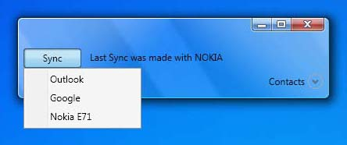

Symmetric synchronization

You do not need specify what sync source is master or slave, which one will be rewrited or not. The symmetric sync algorithm guarants you that no data loss, contacts duplicating or data inconsistance accurse.

The application starts and loads all contacts from Windows Contacts folder by default. That sync source sets up as default. Every sync session performs with the default sync source.

Instant full cross-fields search

|  |  |
| --- | --- |
| http://synrc.com/img/expanded.png | You can find contacts by any data stored within vCARD: phone, e-mail, name, postal address, category, etc. Results are filtered instantly by your typing. |

Open architecture for developers

The application is Open Source and you can implement your own sync source provider for any storage you want be supported by Synrc Contacts Application. You just need to define how to fetch contacts from sync source, update, delete and add them. Most sync source providers are implemented in one screen of code.

Security Issues

No passwords are stored on your computer from your sync sources. Passwords can be remembered only within a life of the application. When the application shutdowns you have to retype passwords. This guarants you that no password leek is possible.

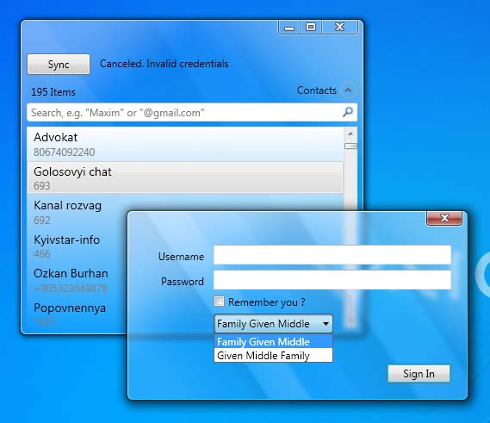

Designed with multithreading in mind

|  |  |
| --- | --- |
| http://synrc.com/img/blue/loading.jpg | The sync Engine uses 7 threads to fetch, synchronize and update sync source. That guarants you that your synchronization will be finished as soon as possible and defines high responsiveness and smoothness of application. |

Supports Windows Sync Center

The application registers the Sync Center Partnership and now you can sync all items in one place along with Windows Mobile Devices and Offline Folders.

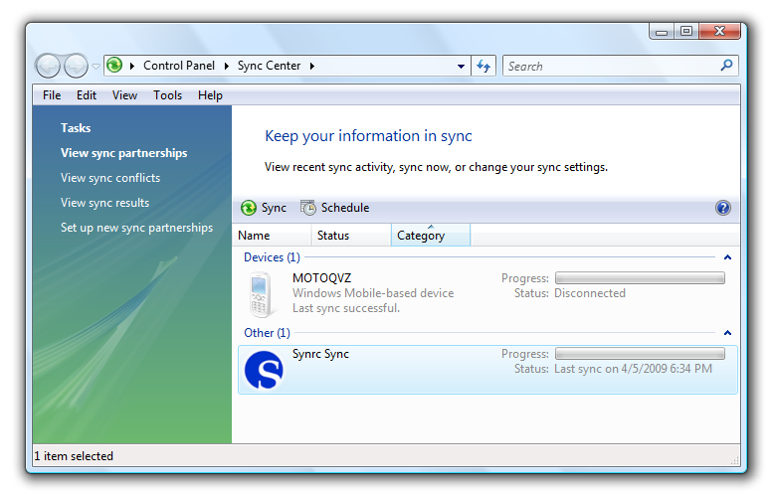

[Privacy Policy](http://synrc.com/privacy.htm) | [Feedback](http://synrc.com/feedback.htm)  
Copyright © 2005—2009 [synrc Research Center, Inc.](http://synrc.com/index.htm)